INTERDIGITATED ELECTRODES IN MICROFLUIDICS

Erin Ingram & Omar Mahmood

**Interface Control Document**

REVISION – 1

4 December, 2022

Interface Control Document

for

Interdigitated Electrodes in Microfluidics

Prepared by:

Erin Ingram and Omar Mahmood, 9/30/22

Authors Date

Approved by:

______________________________

Erin Ingram Date

_____________________________

John Lusher II, P.E. Date

_____________________________

Dalton Cyr Date

**Change Record**

| **Rev.** | **Date** | **Originator** | **Approvals** | **Description** |
| --- | --- | --- | --- | --- |
| **-** | 9/30/22 | Erin Ingram, Omar Mahmood |  | Draft Release |
| **1** | 12/4/2022 | Erin Ingram |  | Revising grammar and formatting errors |

**Table of Contents**

**Table of Contents III**

**List of Tables IV**

**List of Figures V**

**1.** **Overview 1**

**2.** **References and Definitions** 6

2.1. References 6

2.2. Definitions 6

**3.** **Physical Interface** 7

3.1. Weight 7

3.2. Dimensions 7

3.2.1. Dimension of High Pass Unit 7

3.2.2. Dimension of Band Pass Unit 7

3.3. Mounting Locations 8

**4.** **Thermal Interface** 10

**5.** **Electrical Interface** 11

5.1. Primary Input Power 11

5.2. IDE 11

5.3. Video Interfaces 11

5.4 User Control Software 11

**6****.** **Communications / Device Integration** 12

**List of Tables**

Table 1: High Pass Subsystem Weight

Table 2: Band Pass Subsystem Weight

Table 3: High Pass Subsystem Dimensions

Table 4: Band Pass Subsystem Dimensions

**List of Figures**

# Figure 1. 3D rendering of Channel Design

# Figure 2. High Pass Filter physical design

Figure 3. Softlithography chip fabrication using PDMS

# Overview

Provide a brief overview of what this ICD will cover.

This document is provided to detail how the two stages of the droplet filtration system will interface with each other. It will list the inputs, outputs and how the system will manage each input and output. The microfluidic channel and interdigitated electrode arrays will be detailed for both subsystems as well.

# References and Definitions

## References

Refer to section 2.2 of the Functional System Requirements document.

## Definitions

DNA Deoxyribonucleic Acid

IDE Interdigitated Electrode

PCR Polymerase Chain Reaction

PDMS Polydimethylsiloxane

TBD To Be Determined

µm Micrometer

# Physical Interface

Provide details on the physical interface.

## Weight

**3.1.1 High Pass Unit**

| Component | Weight | Number of Items | Total Weight |
| --- | --- | --- | --- |
| High pass channel | TBD | 1 | TBD |
| High pass IDE | TBD | 1 | TBD |

Table 1: High Pass Subsystem Weight

**3.1.2 Band Pass Unit**

| Component | Weight | Number of Items | Total Weight |
| --- | --- | --- | --- |
| Band pass channel | TBD | 1 | TBD |
| Band pass IDE | TBD | 1 | TBD |

Table 2: Band Pass Subsystem Weight

## Dimensions

### Dimension of High Pass Unit

| Component | Length | Width | Height |
| --- | --- | --- | --- |
| High pass channel | 14500 µm | 4020 µm | 120 µm chamfered to 100 µm |
| High pass IDE | TBD | TBD | TBD |

Table 3: High Pass Subsystem Dimensions

### Dimension of Band Pass Unit

| Component | Length | Width | Height |
| --- | --- | --- | --- |
| Band pass channel | 19300 µm | 6400 µm | 120 µm |
| Band pass IDE | TBD | TBD | TBD |

Table 4: Band Pass Subsystem Dimensions



Figure 1. 3D rendering of Channel Design (I: High pass, II: Band pass)

## Mounting Locations

The IDEs for each filter will be placed at the last junctions of both filters (Figure 1). The output of the high pass filter will then be fed into an intermediate PCR* machine using tubing. The output droplets from the PCR equipment will be fed into the band pass filter using tubing. The process of aligning and placing the IDEs onto the microfluidic channels will be done via plasma bonding.

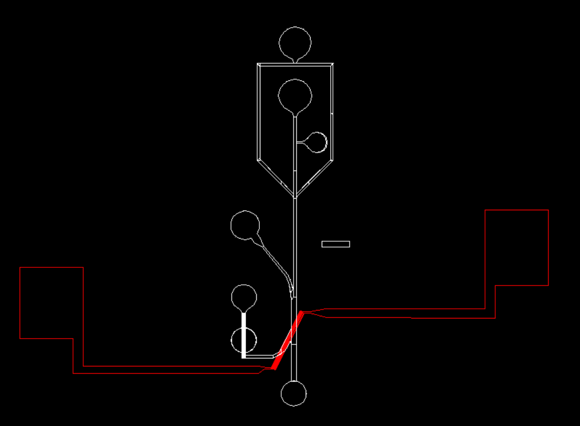

Figure 2. High Pass Filter – channel (white) and aligned IDE (red)

*Polymerase Chain Reaction (PCR) is a process commonly used in biological experiments. It involves rapid replication of DNA for applications such as crime forensics, drug screening and development, and infection diagnostics. This process requires uniform input droplets to trap single DNA molecules inside. To facilitate the process of artificial DNA replication, significant temperature changes take place which disturbs droplets leading to splitting and merging. We are designing our filtration system around the needs and consequences of the PCR process since it is a practical application of the technology.

# Thermal Interface

Provide detail on any thermal interfaces that your project may have. Do you need cooling and air circulation? Do you need heatsinks? If you use a heatsink, does it need a cold wall?

The PDMS used during softlithography for channel fabrication (Figure 3) has a temperature range of -40*℃* to 150*℃*. The IDEs will be fabricated using gold deposition, which has a temperature range of up to to 1000*℃.* Given these broad temperature ranges, it is unlikely that we will need any thermal interfaces for the device.

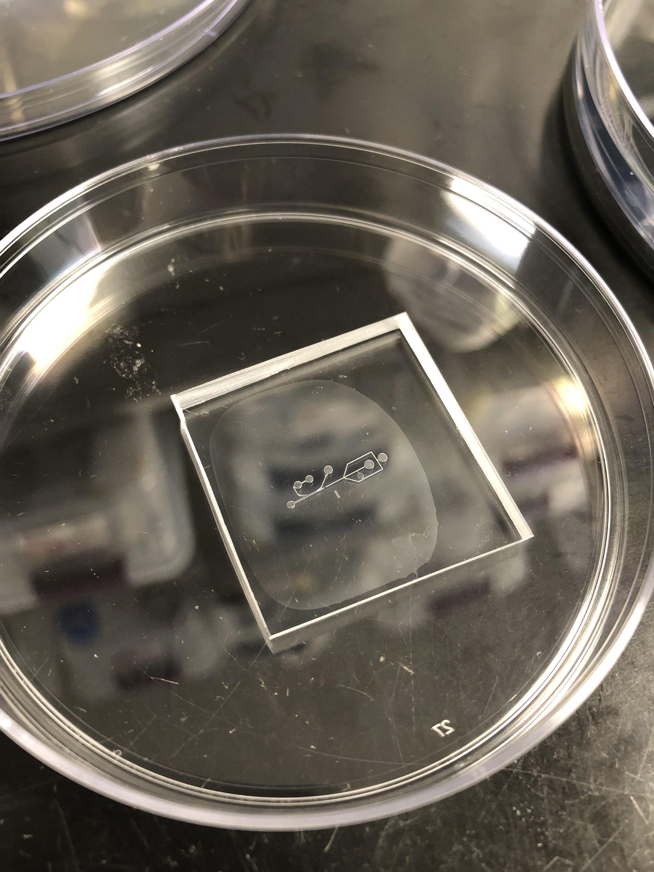

Figure 3. Softlithography chip fabrication using PDMS

# Electrical Interface

Provide details on the electrical interface.

## Primary Input Power

The input power will be a DC source. A connection will be soldered onto the IDE for a battery, and a 9V DC source will be used to power the IDE. The droplets will be pumped into the channel using a syringe pump, which will be connected to a standard wall outlet.

## IDE

The IDE will be used to separate the droplets based on size. It will be fabricated using gold deposition. The power it receives from the DC source will create an electric field between the fingers. When droplets pass through this electric field, they will be sorted to the corresponding output based on size.

## Video Interfaces

During experimentation, a light microscope equipped with a high speed camera (1 million frames per second) will be used to take video recordings of droplet generation and the filtration processes. This will be used during validation to test the success of the device.

## User Control Interface

The user interface of this device will consist of tubing and syringes for inputs to the first stage (high pass filter), output requiring transportation to PCR equipment, and finally a second set of syringes and tubing for input to the second stage (bandpass filter). The user might want to use additional equipment including microscopes and high-speed cameras to validate results of their own applications.

# Communications / Device Interface Protocols

Provide details on the protocols for communication.

This device is an isolated lab-on-a-chip, used to mitigate the problem of unwanted droplet sizes in microfluidics. As such, it does not communicate electronically with other devices or systems.